Memo

Date: February 2001
To: John Sherriff, Richard Lewis, Simon Hastings, Fernley Dyson, Mike Jordan, David Port, Micheal Brown, Ted Murphy, Sally Beck,

From: Mike Wellings/James New
Re: UK Power – January 2001 Curve Validation and Profit and Loss Report
The purpose of this memorandum is to summarise our review of the UK Power Curves used as at the 31st January 2001 and analyse the reported profits of the book.

A- Executive Summary
Having reviewed and validated the 31st January 2001 UK Power Curves and considered the appropriateness of any significant changes in inputs and assumptions, we conclude the curves are fairly constructed with an objective methodology, using the latest data, where available, and are consistent with relevant market information. The profit for the month of January was £18.6m (December £35.5m profit) and the total net assets were £362.8m (December £344.1m).

Of the profit of £18.6m the main drivers were:
- £11.5m profit on forward prices
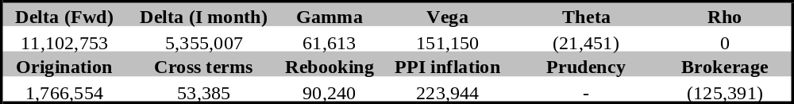
- £7.1m profit due to Intra month and Origination earnings

Further details can be found in the profit and loss commentary under section C.
The number of December trades at 1,027 (December 762 trades) was 35% greater than traded in November.
The most actively traded was largely in the prompt periods - 40% of trades were for January, while 45% of deals were entered into for the Winter 2000 period.
The reduction in forward trading was due to the continued NETA uncertainty. There were doubts that there would unlikely to be any swift return to liquid post-NETA trading until all the uncertainties surrounding the GTMA and the NETA start date are finally resolved, even though a small number of National Balancing Point and Station Gate trades were entered into in the period.
The trades in the period are summarised below:
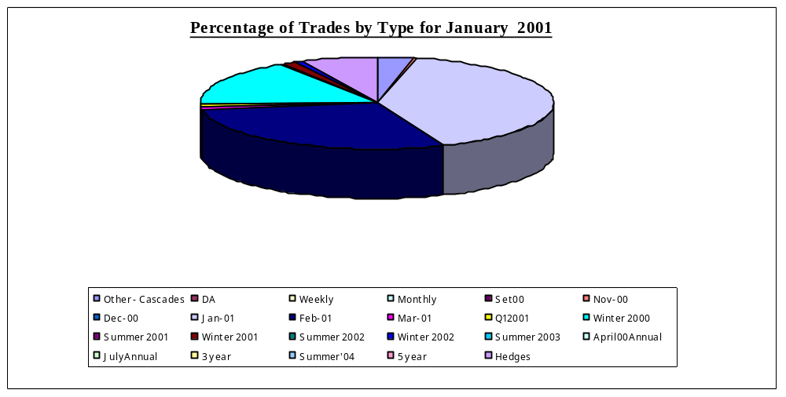

No trades were completed with the UKPX in the review period.

During January 235 trades were completed on Enron Online (EOL) (180 during December) – 26% of total deals (December 27%). Axia Energy Europe Limited were the counter party most frequently traded with 84 trades in the period .
The value of the trades for EOL at 29th December was £(37.1)m, (December £(36.3)m) - during December Enron has taken a long position of approximately 0.8TWh on line. (December short position of 0.7 TWh)
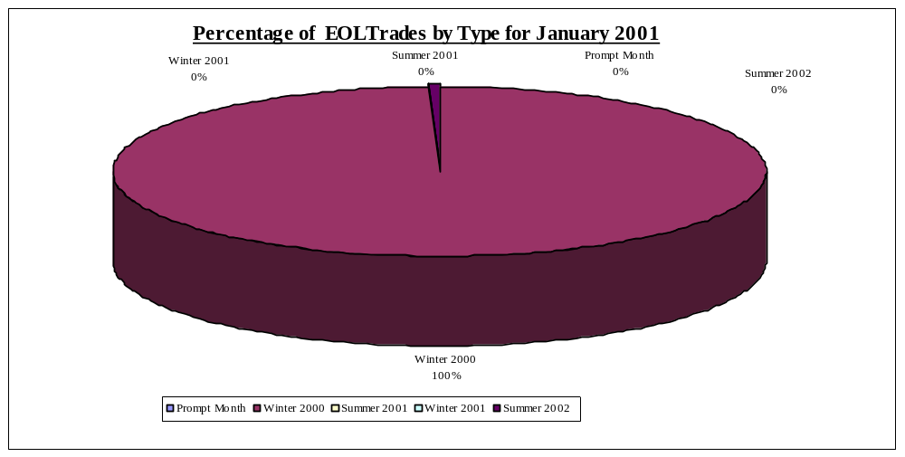The EOL portfolio split for the month are summarised below :

NETA – The period focussed on discussions around the terms of the Grid Trade Master Agreements (“GTMA”) under NETA. Movement has been to define a schedule 5 to the GTMA contract, which will enable post NETA trades. This is designed to be a clause that will enable trades to be entered into at the Station Gate (“SG”) or the National Balancing Point (“NBP”). As this clause is designed to be a calculation of transmission losses and business use of system charges, which is effectively the cost of taking power from the Station Gate to the National Balancing Point, by electing to adopt the clause the costs are passed through – like VAT – and the contract becomes a Station Gate contract. By not adopting the clause the contract would be treated as a full NBP price. In addition an Allen & Overy appendix has been added to a number of trades that effectively convert EFA contracts to NBP contracts with physical trading terms.

B - Curve Validation

1. Methodology
The curves have been reviewed using the following criteria, and have been split in the same way as in the UK Power Market Forward Curves Document (December 2000).
Broker Quote Variance Front End
- Historical Trades / Press reports Middle
- Curve Construction Back End

2. Review – Power Delta

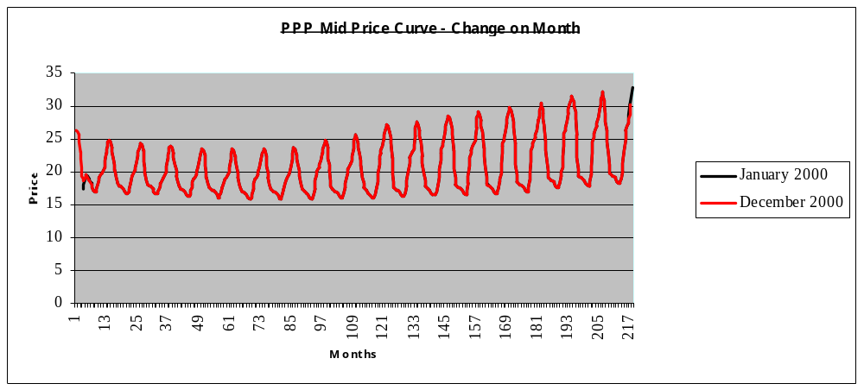The changes in the curve for the month is reflected below:

2.1 Broker Quotes Front End (March 2001 – October 2003)

Broker prices that were available from PH Energy Analysis Limited for different load shapes and time periods were compared with the curve as at 31st January 2001.The total implied understatement of profits was estimated to be £33k (December £91k understated) which was considered immaterial.
The market curve for April Annual was 13p below the broker quotes, giving an estimated overstatement of £63k, Summer and Winter 02 were 11p and 5p above the broker quotes, giving an understatement of £24k and £73k respectively. Other variances, totalling £11k overstated was immaterial.
This method of validation is only relevant for the period for which quotes were available. Therefore, this method only verifies the curve for the first 18 months.
The analysis of the broker quotes for the front end of the curve over the quarter has shown that the traders curves have been consistent. The large movements in the market have been evidenced via the broker quotes, and matched daily to the Enron curves.

2.2 Historical Trades Middle ( 2003 – 2010)

NETA concerns continued to have a major impact on longer term trading. Only one trade was completed in the period a three year March 01 buy of 100MW at £19.40. This is a National Balancing Point trade which generated origination of £630k. This indicted that the curve was understated for the term of this contract. Even though the curve did not move in January it has been reduced significantly in the early part of February to bring the PPP position to a NBP curve. It has been noted that the curve has only moved to the extent of trades entered into (March 2003). The curve to 2010 still needs to be re-marked.

2.3 Curve Construction Back End (2010-2025)
The back end of the curve did not move during January.
Over the long term the curve is partitioned by considering the long-term cost of producing electricity. Using the Gas Forward curve and the latest economics for a 1200MW plant and using Enron’s forecast market heat rate curve it is possible to create a forward cost of power from the latest CCGT i.e. the most efficient plant available.

Full details and support are documented in the Power Market Forward Curves Document (December 2000) .

3 Review – Other Risk Variables
Interest rate risk is not reviewed as all P&L derived from this is passed to the Interest rate book. The UK Power book has in this quarter accrued interest from the NP Accrual Book. This interest is then swapped to the Interest Rate Desk to offset against the negative theta cash flows on the out of the money PPA contract.
The present value of options and swaptions was £(15.3)m (December £(15.0)m) with maturities going out to October 2005 (December - October 2005)
There are no market quotes for implied volatilities. Trades are compared to volatilities implied from option trades completed or reported in the month to ensure consistency. Volatility ladders were calculated to quantify the sensitivity of the portfolio to volatility moves. Enron is net long volatility – . For a base load volatility move of +/- 1% the implied P&L would be a profit of £80k / loss of £84k respectively (November profit of £87k / loss of £93k) For a move of +/- 5% the implied P&L would be a profit of £362k/loss of £360k respectively. In relation to the size of the book the vega sensitivity is not considered material.
There were 22 swaptions / options traded this month by Enron (December 17)

Average results are reflected below – this demonstrates that vega on options reduce as expiration approaches. Therefore, a long-term option will always be more sensitive to a change in volatility than a short term option with similar contract specifications – the more time to expiration gives more time for volatility to take effect.
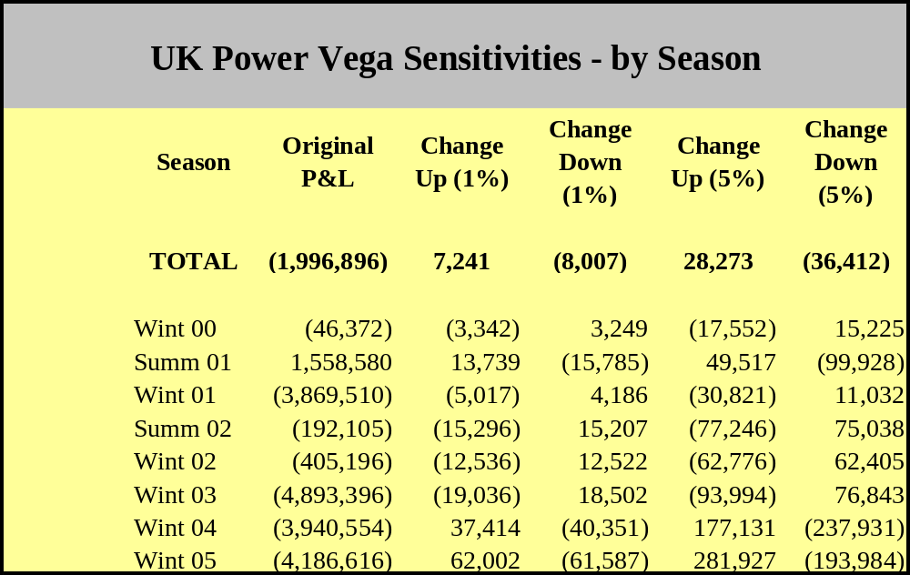

C – P&L Commentary

1. Profit and Loss changes

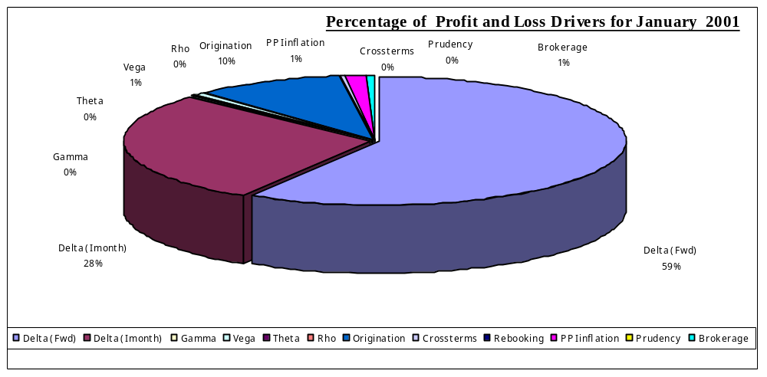
The P&L for January was a profit of £18,657,805 - Income drivers are summarised below

The main changes for the month were:
- Delta Profits of £11.5M The earnings in January were all generated in the prompt periods to March 2000. On our overall short position the curve has come down. The market has been extremely sensitive to the out turn prices in the period, whereby lower than anticipated day ahead out turns have driven down the February and march trading periods.
- 7.1m profit due to Intra month and Origination earnings The prompt trading period – February – generated profits of £5.3 in the period. Out-turn prices have consistently fallen off in the month on the back of bearish trading sentiment, increased system capacity, reduced demand and mild weather in the period.

Realised Profit
The realised profit for January was £18.1m (December 1.0m profit).
- PPP £18.1m profit (December £1.0m loss)
- SMP £0m gain (December £0m gain)
- LOLP £0 loss (December £0m gain)

3. Prudency

None

4. Monthly Curve & Volumeric Movement

- Baseload prices for March 2001 moved up marginally by £0.21/MWh on average – there was no change to any other month, with no shift in baseload prices.

The most actively traded periods were: Winter 2000 (Long 390,380 MWhrs) Summer 2001 (Long 937,556 MWhrs ) Summer 2002 (Long 1,399,376 MWhrs)

The monthly change is reflected below:

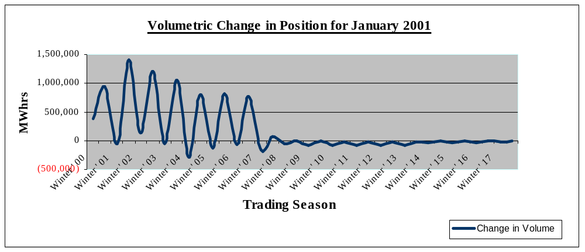

The additional length taken is due to the reduction in the Eastern Option position. The option spreads have narrowed in January, driven by the movement of the UK Gas curve. The curve moved up sharply to 2006. The first year was static, the following 2 years rose 1.4p/therm, followed by a rise of 0.8p/therm – 0.4p/therm over the next 3 years. The winter summer spread also narrowed. Reasons for the curve shift have been identified as – Bullish sentiment, colder weather than earlier in the year and problems at the Brittania field.

5. Energy Trends Electricity

The current MTM of the Energy Trends position as at 31st January was £6,792,364 – December £6,675,821. No announcement has been made on the adoption of the Climate Change Levy (“CCL”), even though initial DTI feedback has indicated that the method of implementation is consistent with the assumptions made in 2000.

6. Value at Risk
The 1day value at risk at 31st January was £9,713,183 using a 5% 1tail confidence interval (December £11,134,717). No violations occurred in the review period. The reduction in Value at Risk in the review period is reflective of the significant length taken in January.

Appendix 1.

Broker Quotes Comparison

Appendix 2.

Curve shift impact and curve movement for PPP

Appendix 3.

Curve shift impact and curve movement for LOLP

Appendix 4.

Curve shift impact and curve movement for SMP

Appendix 5.

Delta Volumes

Appendix 6.

P&L analysis split.

Appendix 7.

Peak / Off Peak / Baseload monthly curve shift and P&L analysis.

Appendix 8.

Graph to show amounts Settled per month and the book Profit for the month.

